**RAJALAKSHMI ENGINEERING COLLEGE [AUTONOMOUS]**

**Laboratory Record Note Book**

**RAJALAKSHMI NAGAR, THANDALAM - 602105**



Name : ……………………………………………………………....

Year / Branch / Section : …………………………………………….

Register No : ………………………………………………………..

College Roll No : ……………………………………………………

Semester : …………………………………………………………...

Academic Year : ……………………………………………………..

**RAJALAKSHMI ENGINEERING COLLEGE RAJALAKSHMI NAGAR, THANDALAM - 602105**



Name :

Academic Year : Semester : Branch :

Register No :

Certified that is the bonafide record of work done by the

above student in the

Laboratory during the year 20 - 20

Signature of Faculty in-charge Submitted for the practical examination held on

Internal Examiner External Examiner

**INDEX**

Reg. No. : Name :

Year : Branch : Sec :

|  |  |  |  |  |
| --- | --- | --- | --- | --- |
| **S.**  **No.** | **Date** | **Title** | **Page No.** | **Teacher’s Signature / Remarks** |
| 1 |  | Create a web page to embed a map along with hot spot AND links |  |  |
| 2 |  | Create a web page using an embedded, external, and inline CSS file |  |  |
| 3 |  | Create a registration page along with validations |  |  |
| 4a |  | JSP - Library Management System |  |  |
| 4b |  | Servlet - Bank Application |  |  |
| 5 |  | PHP – Employee Details to connect database and execute queries to retrieve and update data. Prepare report for single and group of employees based on the end user needs |  |  |
| 6 |  | Bootstrap – Web Page |  |  |
| 7 |  | Design a Web page with Navigation menu, Inline editor, Order form, Instant Search & Switchable Grid. |  |  |
| 8 |  | Angular JS – Single Page Application |  |  |

EXPT NO: Create a web page to embed a map along with hot spot AND links.

DATE:

**AIM**:

To create a web page which includes a map and display the related

information when a hot spot is clicked in the map.

# PROCEDURE:

1. Create a html file with map tag.
2. Set the source attribute of the img tag to the location of the image and also set the use map attribute.
3. Specify an area with name, shape and href set to the appropriate values.
4. Repeat step 3 as many hot spots you want to put in the map.
5. Create html files for each and every hot spot the user will select.

# Code:

**ImageMap.html**

<!DOCTYPE html>

<html lang="en">

<head>

<meta charset="UTF-8">

<meta name="viewport" content="width=device-width, initial-scale=1.0">

<title>Indian States</title>

<style>

body {

font-family: 'Arial', sans-serif; background-color: #f0f0f0; margin: 0;

padding: 0;

text-align: center;

}

img {

display: block; margin: 20px auto; max-width: 100%;

}

a {

color: #333;

text-decoration: none;

}

</style>

</head>

<body>

<img src="india_map.jpg" usemap="#metroid" ismap="ismap">

<map name="metroid" id="metroid">

<area href="TN.html" shape="circle" coords="208,606,50" title="Tamil Nadu"/>

<area href="KA.html" shape="rect" coords="130,531,164,535" title="Karnataka" />

<area href="AP.html" shape="poly" coords="227,490,238,511,230,536,198,535,202,503" title="Andhra Pradesh" />

</map>

</body>

</html>

# TN.html

<HTML><HEAD>

<TITLE>About Tamil Nadu</TITLE>

</HEAD>

<BODY>

<CENTER><H1>Tamil Nadu</H1></CENTER> <HR>

<UL>

<LI>Area : 1,30,058 Sq. Kms.</LI>

<LI>Capital : Chennai</LI>

<LI>Language : Tamil</LI>

<LI>Population : 6,21,10,839</LI> </UL><hr>

<a href='ImageMap.html'>India Map</a>

</BODY>

</HTML>

# KA.html

<HTML>

<HEAD>

<TITLE>About Karnataka</TITLE> </HEAD>

<BODY>

<CENTER><H1>Karnataka</H1></CENTER>

<HR> 5

<UL>

<LI>Area : 1,91,791 Sq. Kms</LI>

<LI>Capital : Bangalore</LI>

<LI>Language : Kannada</LI>

<LI>Population : 5,27,33,958</LI>

</UL>

<hr>

<a href='ImageMap.html'>India Map</a>

</BODY>

</HTML>

# AP.html

<HTML>

<HEAD>

<TITLE>About Andhra Pradesh</TITLE> </HEAD>

<BODY>

<CENTER><H1>Andhra Pradesh</H1></CENTER> <HR>

<UL>

<LI>Area : 2,75,068 Sq. Kms</LI>

<LI>Capital : Hyderabad</LI>

<LI>Language : Telugu</LI>

</UL>

<hr>

<a href='ImageMap.html'>India Map</a>

</BODY>

</HTML>

# Output:

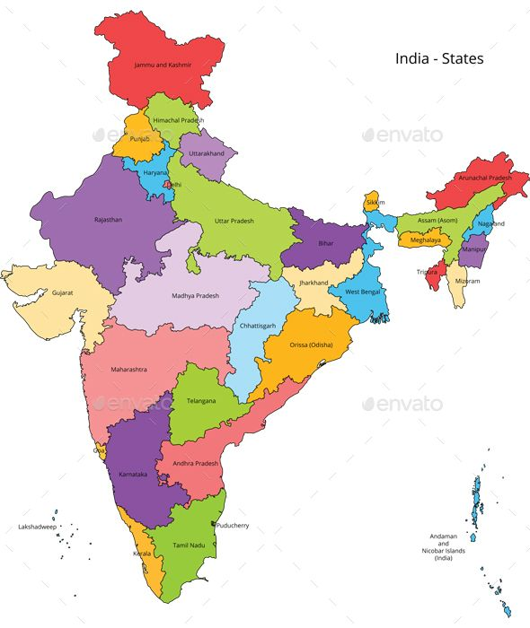

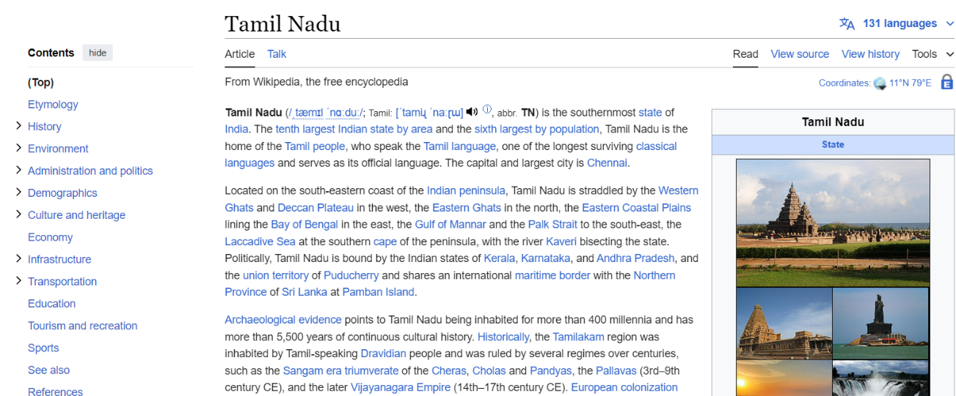

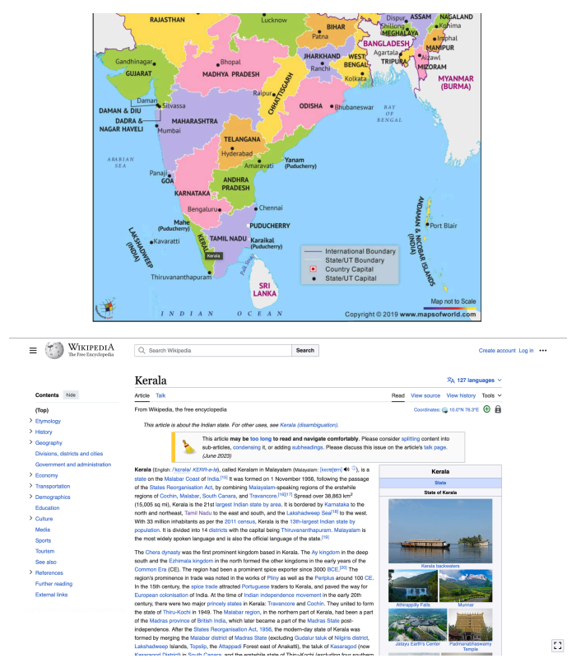

**RESULT**:

Thus the creation of a web page which includes a map and display the related in-formation when a hot spot is clicked in the map was executed successfully.

EXPT NO: Create a web page using an embedded, external, and inline CSS file.

DATE:

**AIM**:

sheet.

To create a web page that displays college information using various style

# PROCEDURE:

1. Create a web page with frame sets consisting two frames
2. In the first frame include the links
3. In the second frame set display the web page of the link
4. Create a external style sheets
5. Create a embedded style sheets
6. Create a inline and internal style sheets and make it link to the external style sheets

# Code:

**Index.html:**

<!DOCTYPE html>

<html lang="en">

<head>

<title>Marvel Fan Page</title>

<link rel="stylesheet" href="style.css">

<style>

body {

font-family: 'Arial', sans-serif; background-color: #f0f0f0; margin: 0;

padding: 0;

text-align: center;

}

/* Inline CSS */

.header {

background-color: #ed1d24; color: #fff;

padding: 20px; text-align: center;

}

img {

display: block; margin: 0 auto;

max-width: 100%;

}

</style>

</head>

<body>

<header class="header">

<h1>Marvel Universe</h1>

</header>

<nav>

<ul>

<li><a href="characters.html">Characters</a></li>

<li><a href="movies.html">Movies</a></li>

<li><a href="comics.html">Comics</a></li>

<li><a href="about.html">About</a></li>

</ul>

</nav>

<img src="marvel.jpg" alt="Marvel Logo">

<h2>Welcome to marvel fan page</h2>

<footer>

<p>&copy; 2024 Marvel Fan Page</p>

</footer>

</body>

</html>

# Characters.html:

<!DOCTYPE html>

<html lang="en">

<head>

<title>Marvel Characters</title>

<link rel="stylesheet" href="style.css">

</head>

<body>

<h1>Marvel Characters</h1>

<img src="The_Marvel_Universe.webp" alt="Marvel Characters">

<p>Explore the amazing world of Marvel characters! From Iron Man to Spider- Man, and from Black Widow to Thor, Marvel has brought to life some of the most iconic heroes and villains in comic book history.</p>

</body>

</html>

# Placement.html:

<!DOCTYPE html>

<html lang="en">

<head>

<title>Marvel Movies</title>

<link rel="stylesheet" href="style.css">

</head>

<body>

<h1>Marvel Movies</h1>

<img src="Marvel_Cinematic_Universe_logo.png" alt="Marvel Movies">

<p>Marvel movies have taken the world by storm! From the Avengers series to standalone films like Black Panther and Captain Marvel, the Marvel Cinematic Universe (MCU) has become a cultural phenomenon.</p>

</body>

</html>

# Output:

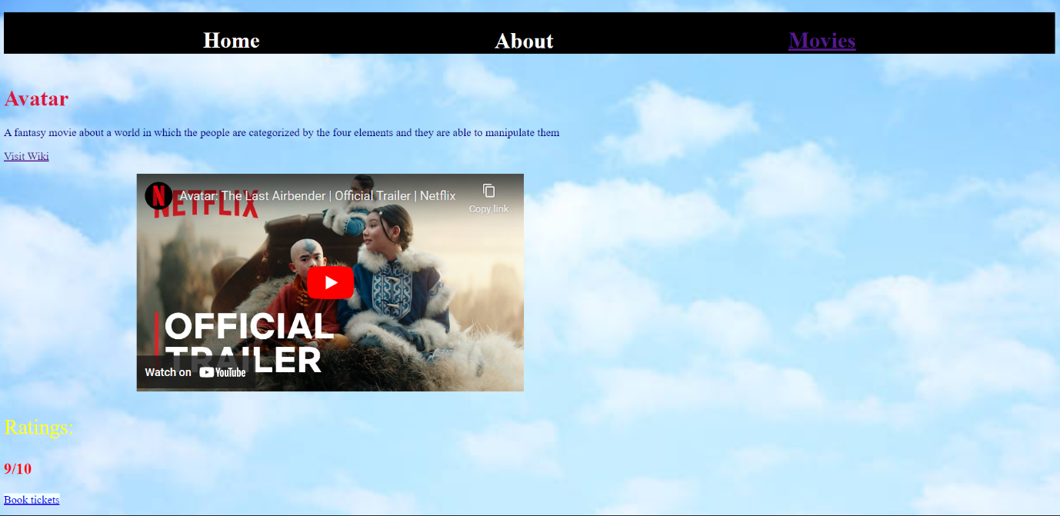

**

**RESULT:**

Thus the creation of a web page that displays college information using various style sheet was successfully executed and verified.

EXPT NO: Create a registration page along with validations.

DATE:

# Aim:

To create a visually appealing registration form with validation for email

addresses.

# Procedure:

1. Layout Design:

Design the layout of the registration form, including input fields for username, email, and password, along with a submit button.

1. Styling:

Apply CSS to style the form elements, providing appropriate spacing, alignment, and background color to enhance visual appeal.

1. Email Validation:

Implement JavaScript to validate the email address entered by the user. Ensure that the email follows the standard format and contains the "@" symbol.

1. Error Handling:

Display error messages if the email entered by the user is invalid. These messages should provide clear guidance on how to correct the input.

1. Submission Handling:

Handle form submission events, ensuring that the form data is submitted only if all fields are filled correctly, including a valid email address. If any field is invalid, prevent form submission and prompt the user to correct the errors.

# Code:

**Index.html:**

<!DOCTYPE html>

<html lang="en">

<head>

<title>Registration Page</title>

<link rel="stylesheet" href="style.css">

</head>

<body>

<div class="container">

<h1>Register Now</h1>

<form id="registrationForm" action="#" method="post">

<div class="form-group">

<label for="username">Username:</label>

<input type="text" id="username" name="username" required>

</div>

<div class="form-group">

<label for="email">Email:</label>

<input type="email" id="email" name="email" required>

<span class="error-message" id="emailError"></span>

</div>

<div class="form-group">

<label for="password">Password:</label>

<input type="password" id="password" name="password" required>

</div>

<button type="submit">Register</button>

</form>

</div>

<script src="script.js"></script>

</body>

</html>

# Style.css:

body {

font-family: 'Segoe UI', Tahoma, Geneva, Verdana, sans-serif; background-color: #f8f8f8;

display: flex;

justify-content: center; align-items: center; height: 100vh; margin: 0;

}

.container { width: 400px; padding: 20px;

background-color: #fff; border-radius: 10px;

box-shadow: 0 0 20px rgba(0, 0, 0, 0.1);

}

h1 {

text-align: center; margin-bottom: 30px; color: #333;

}

.form-group {

margin-bottom: 25px;

}

label {

display: block; margin-bottom: 10px; color: #555;

}

input[type="text"], input[type="email"], input[type="password"] {

width: calc(100% - 20px); padding: 12px;

border-radius: 6px; border: 1px solid #ccc;

}

.error-message { color: #ff0000; font-size: 14px; margin-top: 5px; display: block;

}

button {

background-color: rgb(144, 0, 255); color: #fff;

border: none; padding: 12px 20px;

border-radius: 6px; cursor: pointer; width: 100%;

}

button:hover {

background-color: #0056b3;

}

# Script.js:

document.addEventListener('DOMContentLoaded', function () { const form = document.getElementById('registrationForm'); const emailInput = document.getElementById('email');

const emailError = document.getElementById('emailError'); form.addEventListener('submit', function (event) {

if (!validateEmail(emailInput.value)) { emailError.textContent = 'Invalid email address'; event.preventDefault();

} else {

emailError.textContent = '';

}

});

function validateEmail(email) {

const regex = /^[^\s@]+@[^\s@]+\.[^\s@]+$/; return regex.test(email);

}

});

# Output:

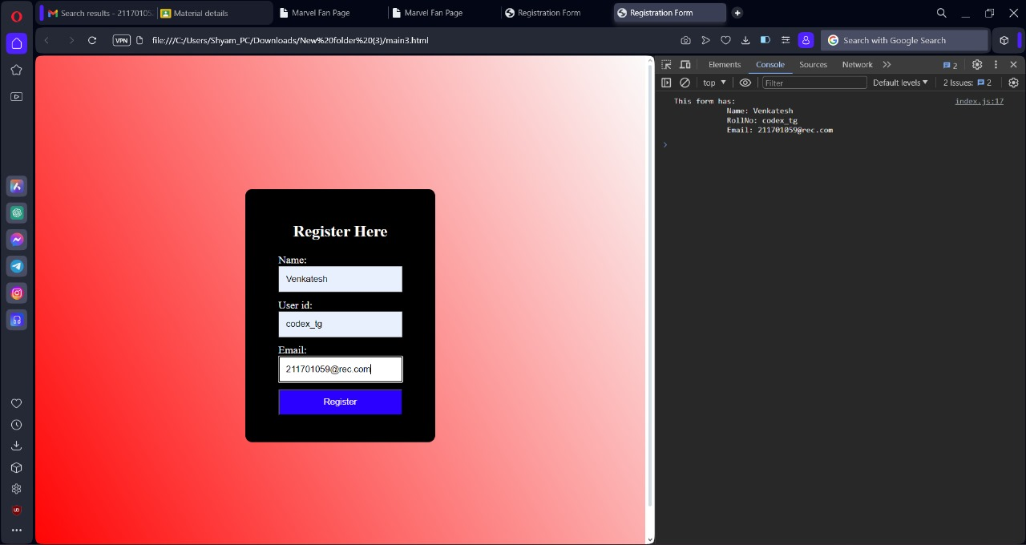

**RESULT:**

A visually appealing registration form with email validation ensures user inputs adhere to standard email format, enhancing data accuracy and user experience.

EXPT NO: JSP - LIBRARY MANAGEMENT SYSTEM DATE:

# Aim:

To develop a JavaScript program that validates the controls in the forms

of the Library Management System application, ensuring data integrity and user input correctness.

# Procedure:

1. Identify forms requiring validation in the Library Management System.
2. Define validation rules for each form field.
3. Develop JavaScript functions for validation based on defined rules.
4. Integrate validation functions with form submission processes.
5. Prevent form submission if data fails validation, display error messages.
6. Thoroughly test and debug the validation functionality for usability and reliability.

# Code:

**Index.html:**

<!DOCTYPE html>

<html lang="en">

<head>

<title>Library Management System</title>

<link rel="stylesheet" href="styles.css">

</head>

<body>

<div class="container">

<h2>Library Management System</h2>

<form id="bookForm">

<div class="form-group">

<label for="title">Title:</label>

<input type="text" id="title" name="title" required>

</div>

<div class="form-group">

<label for="author">Author:</label>

<input type="text" id="author" name="author" required>

</div>

<div class="form-group">

<label for="year">Year:</label>

<input type="number" id="year" name="year" required>

</div>

<button type="submit">Add Book</button>

</form>

<table id="bookTable">

<thead>

<tr>

<th>Title</th>

<th>Author</th>

<th>Year</th>

<th>Action</th>

</tr>

</thead>

<tbody>

<!-- Book rows will be inserted here dynamically -->

</tbody>

</table>

</div>

<script src="script.js"></script>

</body>

</html>

# Styles.css:

body {

font-family: Arial, sans-serif; background-color: #f0f0f0; margin: 0;

padding: 0;

}

.container {

max-width: 800px; margin: 20px auto; padding: 20px; background-color: #fff; border-radius: 5px;

box-shadow: 0 0 10px rgba(0, 0, 0, 0.1);

}

h2 {

text-align: center;

}

.form-group {

margin-bottom: 20px;

}

.form-group label { display: block; margin-bottom: 5px;

}

.form-group input[type="text"],

.form-group input[type="number"] { width: 100%;

padding: 8px;

margin-bottom: 10px; border: 1px solid #ccc; border-radius: 4px;

}

button[type="submit"] { width: 100%; padding: 8px;

background-color: #4CAF50; color: white;

border: none; border-radius: 4px; cursor: pointer;

transition: background-color 0.3s;

}

button[type="submit"]:hover { background-color: #45a049;

}

table {

width: 100%;

border-collapse: collapse;

}

th, td {

padding: 8px;

border-bottom: 1px solid #ddd; text-align: left;

}

th {

background-color: #f2f2f2;

}

tr:hover {

background-color: #f5f5f5;

}

# Script.js:

document.addEventListener('DOMContentLoaded', function () { const bookForm = document.getElementById('bookForm'); const bookTable = document.querySelector('#bookTable tbody'); bookForm.addEventListener('submit', function (event) {

event.preventDefault();

const title = document.getElementById('title').value; const author = document.getElementById('author').value; const year = document.getElementById('year').value; addBook(title, author, year);

bookForm.reset();

});

function addBook(title, author, year) { const row = bookTable.insertRow(); row.innerHTML = `

<td>${title}</td>

<td>${author}</td>

<td>${year}</td>

<td><button class="edit-btn">Edit</button></td>

`;

row.querySelector('.edit-btn').addEventListener('click', function () { editBook(row);

});

}

function editBook(row) {

const title = row.cells[0].textContent; const author = row.cells[1].textContent; const year = row.cells[2].textContent;

const newTitle = prompt('Enter new title:', title);

const newAuthor = prompt('Enter new author:', author); const newYear = prompt('Enter new year:', year);

if (newTitle && newAuthor && newYear) { row.cells[0].textContent = newTitle; row.cells[1].textContent = newAuthor; row.cells[2].textContent = newYear;

}

}

});

# Output:

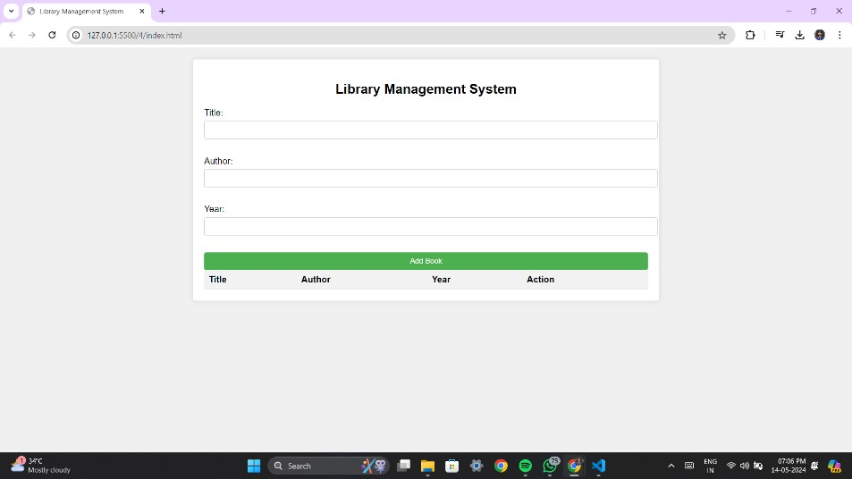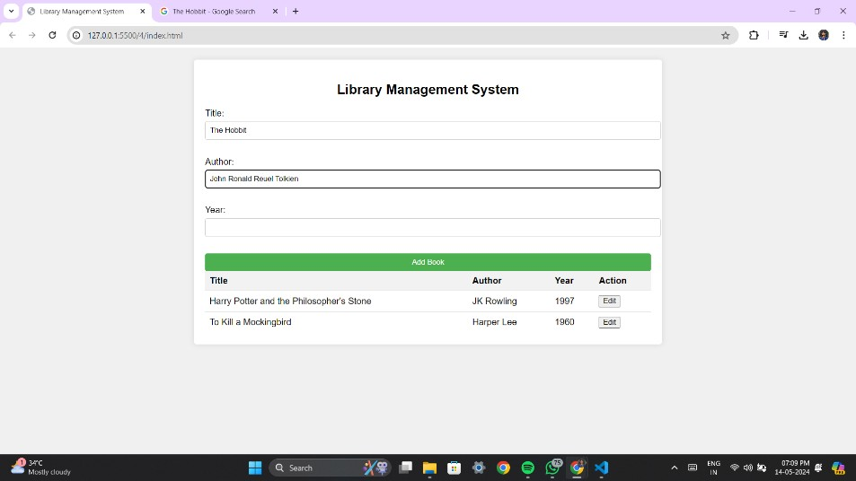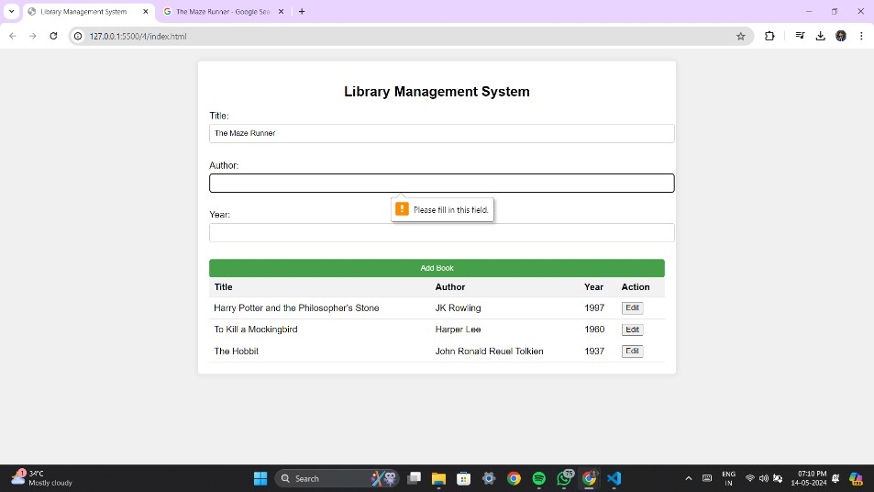

**Result:**

Developed JavaScript program to validate Library Management System forms, ensuring data integrity and input correctness.

EXPT NO: Servlet - Bank Application DATE:

# Aim:

Program to develop a Banking application accessing a database using Servlet.

# Procedure:

Relations using MYSQL for a banking application given below enforcing primary key and

foreign key constraints:

CUSTOMER (CID, CNAME)

ACCOUNT (ANO, ATYPE, BALANCE, CID)

An account can be a savings account or a current account. Check ATYPE in ‘S’ or ‘C’.

A customer can have both types of accounts. TRANSACTION (TID, ANO, TTYPE, TDATE, TAMOUNT)

TTYPE can be ‘D’ or ‘W’

D- Deposit; W – Withdrawal

1. Open MySQL.
2. Create a database.

mysql> create database banking; Query OK, 1 row affected (0.05 sec)

1. Connect to the database. mysql> use banking; Database changed
2. Create the following tables:

mysql> create table customer (cid integer, cname varchar(20),

-> primary key (cid));

# index.html:

<!DOCTYPE html>

<html>

<head>

<meta charset="ISO-8859-1">

<title>Banking Application</title>

</head>

<body>

<h1 align="center">Banking Application</h1>

<hr />

<a href="Customer.html">Customer Details</a>

<br />

<br />

<a href="Account.html">Account Details</a>

</body>

</html>

# Customer.html:

<!DOCTYPE html>

<html>

<head>

<meta charset="ISO-8859-1">

<title>Customer Details</title>

</head>

<body>

<h1 align="center">Customer Details</h1>

<hr />

<form action="AddCustomer" method="post">

<table>

<tr>

</tr>

<tr>

</tr>

<tr>

</tr>

</table>

<td>Customer Id. :</td>

<td><input type="text" name="cid"></td>

<td>Customer Name :</td>

<td><input type="text" name="cname"></td>

<td colspan="2" align="center"><input type="submit" value="Add Customer"></td>

<br /> <a href="ViewCustomers">View All Customers</a>

</form>

</body>

</html>

# AddCustomer.java:

import java.io.IOException; import java.io.PrintWriter; import java.sql.Connection; import java.sql.DriverManager;

import java.sql.PreparedStatement;

import javax.servlet.ServletException; import

javax.servlet.annotation.WebServlet; import javax.servlet.http.HttpServlet; import javax.servlet.http.HttpServletRequest;

import javax.servlet.http.HttpServletResponse;

/**

* Servlet implementation class AddCustomer

*/ @WebServlet("/AddCustomer")

public class AddCustomer extends HttpServlet { private static final long serialVersionUID = 1L;Connection conn = null; PreparedStatement ps = null;

/**

* @see HttpServlet#doPost(HttpServletRequest request, HttpServletResponse
* response)

*/

protected void doPost(HttpServletRequest request, HttpServletResponseresponse)

throws ServletException, IOException {

// TODO Auto-generated method stub response.setContentType("text/html"); PrintWriter out = response.getWriter(); out.println("<html>");

out.println("<head><title>Add Customer Details</title></head>"); out.println("<body>");

out.println("<h1 align='center'>Add Customer Details</h1>"); out.println("<hr />");

try {

Class.forName("com.mysql.cj.jdbc.Driver");

String URL = "jdbc:mysql://localhost:3306/banking";

conn = DriverManager.getConnection(URL, "root", "admin");

ps = conn.prepareStatement("insert customer values (?, ?)"); ps.setInt(1, Integer.parseInt(request.getParameter("cid"))); ps.setString(2, request.getParameter("cname"));

int res = ps.executeUpdate(); if (res != 0)

out.println("Customer Details Inserted Successfully...");

else

out.println("Customer Details Insertion Failure..."); ps.close();

conn.close();

} catch (Exception e) { out.println(e);

}

out.println("<br />");

out.println("<a href='Customer.html'>Back</a>"); out.println("</body></html>");

}

}

# ViewCustomers.java:

import java.io.IOException; import java.io.PrintWriter; import java.sql.Connection; import

java.sql.DriverManager;

import java.sql.PreparedStatement; import java.sql.ResultSet;

import javax.servlet.ServletException; import javax.servlet.annotation.WebServlet; import javax.servlet.http.HttpServlet; import javax.servlet.http.HttpServletRequest;

import javax.servlet.http.HttpServletResponse;

/**

* Servlet implementation class ViewCustomers

*/ @WebServlet("/ViewCustomers")

public class ViewCustomers extends HttpServlet { private static final long serialVersionUID = 1L;Connection conn = null; PreparedStatement ps = null;

ResultSet rs = null;

/**

* @see HttpServlet#doPost(HttpServletRequest request, HttpServletResponse
* response)

*/

protected void doGet(HttpServletRequest request, HttpServletResponseresponse)

throws ServletException, IOException {

// TODO Auto-generated method stub response.setContentType("text/html"); PrintWriter out = response.getWriter(); out.println("<html>"); out.println("<head><title>View All Customer

Details</title></head>"); out.println("<body>");

out.println("<h1 align='center'>View All Customer Details</h1>"); out.println("<hr />");

try { Class.forName("com.mysql.cj.jdbc.Driver");

String URL = "jdbc:mysql://localhost:3306/banking";

conn = DriverManager.getConnection(URL, "root", "admin"); ps = conn.prepareStatement("select * from customer order bycid");

rs = ps.executeQuery(); out.println("<table border='1'>"); out.println("<tr>"); out.println("<td>Customer Id.</td>"); out.println("<td>Customer Name</td>"); out.println("<td>Edit</td>"); out.println("<td>Delete</td>"); out.println("</tr>");

while (rs.next()) { out.println("<tr>");

out.println("<td>" + rs.getInt("cid") + "</td>"); out.println("<td>"

+ rs.getString("cname") + "</td>");out.println("<td><a href='EditCustomer?cid=" + rs.getInt("cid") + "'>Edit</a></td>"); out.println("<td><a href='DeleteCustomer?cid=" + rs.getInt("cid")

+ "'>Delete</a></td>"); out.println("</tr>");

}

out.println("</table>"); ps.close();

conn.close();

} catch (Exception e) {

out.println(e);

}

out.println("<br />");

out.println("<a href='Customer.html'>Back</a>"); out.println("</body></html>");

}

}

# EditCsutomer.java:

import java.io.IOException; import java.io.PrintWriter; import java.sql.Connection; import java.sql.DriverManager;

import java.sql.PreparedStatement; import java.sql.ResultSet;

import javax.servlet.ServletException; import javax.servlet.annotation.WebServlet; import javax.servlet.http.HttpServlet; import javax.servlet.http.HttpServletRequest;

import javax.servlet.http.HttpServletResponse;

/**

* Servlet implementation class EditCustomer

*/ @WebServlet("/EditCustomer")

public class EditCustomer extends HttpServlet { private static final long serialVersionUID = 1L;Connection conn = null;

PreparedStatement ps = null; ResultSet rs = null;

/**

* @see HttpServlet#doGet(HttpServletRequest request, HttpServletResponse
* response)

*/

protected void doGet(HttpServletRequest request, HttpServletResponseresponse)

throws ServletException, IOException {

// TODO Auto-generated method stub response.setContentType("text/html"); PrintWriter out = response.getWriter(); out.println("<html>");

out.println("<head><title>Edit Customer Details</title></head>"); out.println("<body>");

out.println("<h1 align='center'>Edit All Customer Details</h1>"); out.println("<hr />");

try { Class.forName("com.mysql.cj.jdbc.Driver");

String URL = "jdbc:mysql://localhost:3306/banking";

conn = DriverManager.getConnection(URL, "root", "admin");ps = conn.prepareStatement("select * from customer where cid = ?"); ps.setInt(1,Integer.parseInt(request.getParameter(("cid"))));rs = ps.executeQuery();

rs.next();

out.println("<form action='UpdateCustomer' method='post'>"); out.println("<table>");

out.println("<tr>"); out.println("<td>Customer Id.

:</td>");

out.println("<td><input type='text' name='cid' value='" +rs.getInt("cid")

+ "' readonly></td>"); out.println("</tr>"); out.println("<tr>");

out.println("<td>Customer Name :</td>"); out.println("<td><input type='text' name='cname' value='" +rs.getString("cname") + "'></td>"); out.println("</tr>");

out.println("<tr>");

out.println("<td colspan='2' align='center'><inputtype='submit' value='Update Customer'></td>"); out.println("</tr>"); out.println("</table>");

out.println("</form>"); ps.close();

conn.close();

} catch (Exception e) { out.println(e);

}

out.println("<br />");

out.println("<a href='ViewCustomers'>Back</a>"); out.println("</body></html>");

}

}

# UpdateCustomer.java:

import java.io.IOException; import java.io.PrintWriter; import java.sql.Connection; import

java.sql.DriverManager;

import java.sql.PreparedStatement;

import javax.servlet.ServletException; import javax.servlet.annotation.WebServlet; import javax.servlet.http.HttpServlet; import javax.servlet.http.HttpServletRequest;

import javax.servlet.http.HttpServletResponse;

/**

* Servlet implementation class UpdateCustomer

*/ @WebServlet("/UpdateCustomer")

public class UpdateCustomer extends HttpServlet { private static final long serialVersionUID = 1L;Connection conn = null; PreparedStatement ps = null;

/**

* @see HttpServlet#doPost(HttpServletRequest request, HttpServletResponse response)

*/

protected void doPost(HttpServletRequest request, HttpServletResponseresponse)

throws ServletException, IOException {

// TODO Auto-generated method stub response.setContentType("text/html"); PrintWriter out = response.getWriter(); out.println("<html>");

out.println("<head><title>Update Customer Details</title></head>"); out.println("<body>");

out.println("<h1 align='center'>Update Customer Details</h1>"); out.println("<hr />");

try { Class.forName("com.mysql.cj.jdbc.Driver");

String URL = "jdbc:mysql://localhost:3306/banking";

conn = DriverManager.getConnection(URL, "root", "admin"); ps = conn.prepareStatement("update customer set cname = ?where cid = ?"); ps.setString(1, request.getParameter("cname")); ps.setInt(2, Integer.parseInt(request.getParameter("cid")));int res = ps.executeUpdate();

if (res != 0)

out.println("Customer Details Updated Successfully...");

else

out.println("Customer Details Updation Failure..."); ps.close();

conn.close();

} catch (Exception e) { out.println(e);

}

out.println("<br />");

out.println("<a href='ViewCustomers'>Back</a>"); out.println("</body></html>");

}

}

# DeleteCustomer.java:

import java.io.IOException; import java.io.PrintWriter; import java.sql.Connection; import java.sql.DriverManager;

import java.sql.PreparedStatement;

import javax.servlet.ServletException; import javax.servlet.annotation.WebServlet; import javax.servlet.http.HttpServlet; import javax.servlet.http.HttpServletRequest;

import javax.servlet.http.HttpServletResponse;

/**

* Servlet implementation class DeleteCustomer

*/ @WebServlet("/DeleteCustomer")

public class DeleteCustomer extends HttpServlet { private static final long serialVersionUID = 1L;Connection conn = null; PreparedStatement ps = null;

/**

* @see HttpServlet#doGet(HttpServletRequest request, HttpServletResponseresponse)

*/

protected void doGet(HttpServletRequest request, HttpServletResponseresponse)

throws ServletException, IOException {

// TODO Auto-generated method stub response.setContentType("text/html"); PrintWriter out = response.getWriter();

out.println("<html>");

out.println("<head><title>Delete Customer Details</title></head>"); out.println("<body>");

out.println("<h1 align='center'>Delete Customer Details</h1>"); out.println("<hr />");

try { Class.forName("com.mysql.cj.jdbc.Driver");

String URL = "jdbc:mysql://localhost:3306/banking";

conn = DriverManager.getConnection(URL, "root", "admin"); ps = conn.prepareStatement("delete from customer where cid =

?");

ps.setInt(1, Integer.parseInt(request.getParameter("cid"))); int res = ps.executeUpdate();

if (res != 0)

out.println("Customer Details Deleted uccessfully..."); else

out.println("Customer Details Deletion Failure..."); ps.close();

conn.close();

} catch (Exception e) { out.println(e);

}

out.println("<br />");

out.println("<a href='ViewCustomers'>Back</a>"); out.println("</body></html>");

}

}

# Output:

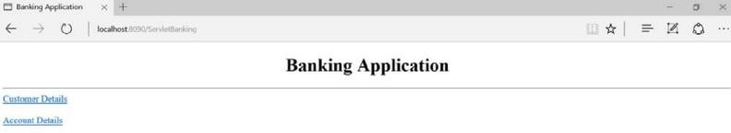

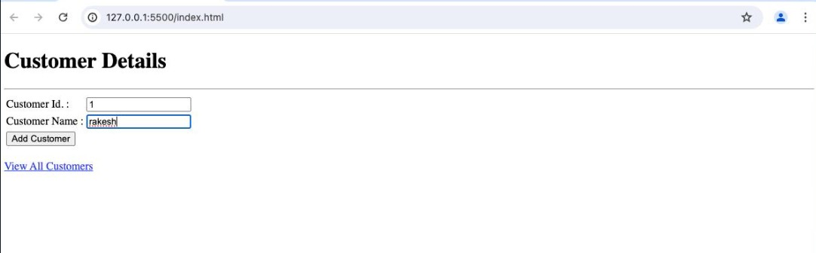

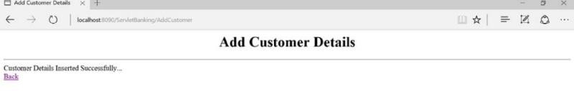

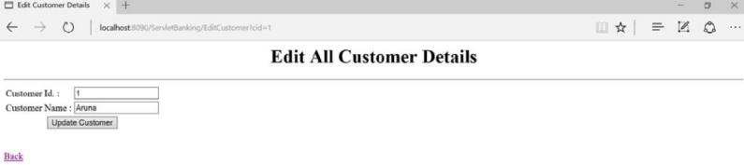

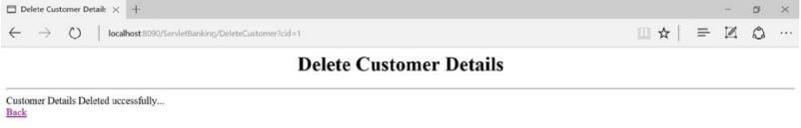

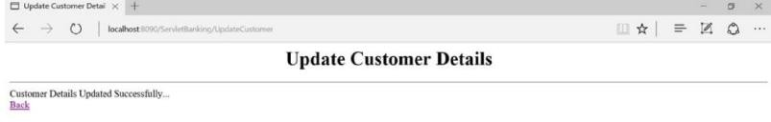

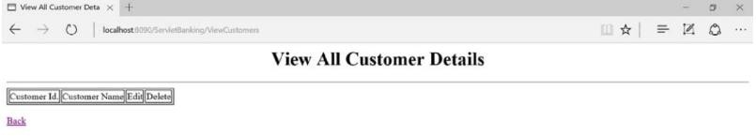

**Result:**

Hence developed a Banking application accessing a database using Servlet is implemented successfully.

EXPT NO: PHP – Employee Details DATE:

# Aim:

PHP program for Employee Details, which includes EmpID, Name,

Designation, Salary, DOJ, etc., to connect with the database and execute queries to retrieve and update data.

# Procedure:

Relations using MYSQL for a banking application given below enforcing primary key and

foreign key constraints:

EMPDETAILS (EMPID, ENAME, DESIG, DEPT, DOJ, SALARY)

1. Open MySQL.
2. Create a database. mysql> create database rec;

Query OK, 1 row affected (0.05 sec)

1. Connect to the database. mysql> use rec;

Database changed

1. Create the following tables:

mysql> create table empdetails(empid int primary key,

-> ename varchar(20), desig varchar(20), dept varchar(20),

-> doj date, salary int);

Query OK, 0 rows affected (0.08 sec)

# PROGRAM:

**config.php**

<?php

$databaseHost = 'localhost';

$databaseName = 'rec';

$databaseUsername = 'root';

$databasePassword = 'admin';

$mysqli = mysqli_connect($databaseHost, $databaseUsername,

$databasePassword, $databaseName);

?>

# index.php

<?php

//including the database connection file include_once("config.php");

//fetching data in descending order (lastest entry first)

$result=mysqli_query($mysqli, "SELECT * FROM empdetails ORDER BY empid DESC");

?>

<html>

<head>

<title>Homepage</title>

</head>

<body>

<h1 align="center">Employee Details</h1>

<hr />

<a href="add.html">Add New Data</a><br/><br/>

<table width='100%' border=0>

<tr bgcolor='#CCCCCC'>

<td>Employee Id.</td>

<td>Name</td>

<td>Designation</td>

<td>Department</td>

<td>DOJ</td>

<td>Salary</td>

<td>Edit / Delete</td>

</tr>

<?php

while($res = mysqli_fetch_array($result)) {echo "<tr>";

echo "<td>".$res['empid']."</td>";

echo "<td>".$res['ename']."</td>";

echo "<td>".$res['desig']."</td>";

echo "<td>".$res['dept']."</td>";

echo "<td>".$res['doj']."</td>";

echo "<td>".$res['salary']."</td>";

echo "<td><a href='edit.php?empid=$res[empid]'>Edit</a>";

echo " | <a href='delete.php?empid=$res[empid]'>Delete</a></td>";echo "</tr>";

}

?>

</table>

</body>

</html>

# add.html

<html>

<head>

<title>Add Employee Details</title>

</head>

<body>

<h1 align="center">Add Employee Details</h1>

<hr />

<a href="index.php">Home</a>

<br /><br />

<form action="add.php" method="post" name="form1">

<table width="25%" border="0">

<tr>

<td>Employee Id. : </td>

<td><input type="text" name="empid"></td>

</tr>

<tr>

<td>Name : </td>

<td><input type="text" name="ename"></td>

</tr>

<tr>

<td>Designation : </td>

<td><input type="text" name="desig"></td>

</tr>

<tr>

<td>Department</td>

<td><input type="text" name="dept"></td>

</tr>

<tr>

<td>DOJ</td>

<td><input type="text" name="doj"></td

</tr>

<tr>

<td>Salary</td>

<td><input type="text" name="salary"></td>

</tr>

<tr>

<td colspan="2" align="center"><input type="submit" name="Submit" value="Add"></td>

</tr>

</table>

</form>

</body>

</html> add.php

<html>

<head>

<title>Add Employee Details</title>

</head>

<body>

<?php

//including the database connection file include_once("config.php");

$empid = $_POST['empid'];

$ename = $_POST['ename'];

$desig = $_POST['desig'];

$dept = $_POST['dept'];

$doj = $_POST['doj'];

$salary = $_POST['salary']; if(isset($_POST['Submit'])) {

//insert data to database

$result = mysqli_query($mysqli, "INSERT INTO empdetails values ($empid, '$ename','$desig','$dept','$doj',$salary)");

//display success message

echo "<h1 align='center'>Add Employee Details</h1>";echo "<hr />";

echo "<font color='green'>Data added successfully.";echo "<br/><a href='index.php'>View Result</a>";

}

?>

</body>

</html>

# edit.php

<?php

// including the database connection file include_once("config.php"); if(isset($_POST['update']))

{

$empid = $_POST['empid'];

$ename = $_POST['ename'];

$desig = $_POST['desig'];

$dept = $_POST['dept'];

$doj = $_POST['doj'];

$salary = $_POST['salary'];

//updating the table

$result = mysqli_query($mysqli, "UPDATE empdetails SET ename='$ename', desig='$desig',dept='$dept',doj='$doj',salary=$salary WHERE empid=$empid");

//redirectig to the display page. In our case, it is index.phpheader("Location: index.php");

}

?>

<?php

echo "<h1 align='center'>Edit Employee Details</h1>";echo "<hr

/>";

//getting id from url

$empid = $_GET['empid'];

//selecting data associated with this particular eid

$result = mysqli_query($mysqli, "SELECT * FROM empdetails WHERE empid=$empid");

while($res = mysqli_fetch_array($result))

{

$empid = $res['empid'];

$ename = $res['ename'];

$desig = $res['desig'];

$dept = $res['dept'];

$doj = $res['doj'];

$salary = $res['salary'];

}

?>

<html>

<head>

<title>Edit Employee Details</title>

</head>

<body>

<a href="index.php">Home</a>

<br/><br/>

<form name="empform" method="post" action="edit.php">

<table border="0">

<tr>

<td>Name : </td>

<td><input type="text" name="ename" value="<?php echo $ename;?>"></td>

</tr>

<tr>

<tr>

<td>Designation : </td>

<td><input type="text" name="desig" value="<?php echo $desig;?>"></td>

</tr>

<tr>

<td>Department : </td>

<td><input type="text" name="dept" value="<?php echo $dept;?>"></td>

</tr>

<td>DOJ : </td>

<td><input type="text" name="doj" value="<?php echo $doj;?>"></td>

</tr>

<tr>

<td>Salary</td>

<td><input type="text" name="salary" value="<?php echo $salary;?>"></td>

</tr>

<tr>

<td><input type="hidden" name="empid" value=<?php echo

$_GET['empid'];?>></td>

<td><input type="submit" name="update" value="Update"></td>

</tr>

</table>

</form>

</body>

</html>

# delete.php

<?php

//including the database connection file include("config.php");

//getting id of the data from url

$empid = $_GET['empid'];

//deleting the row from table

$result = mysqli_query($mysqli, "DELETE FROM empdetails WHERE empid=$empid");

//redirecting to the display page (index.php in our case) header("Location:index.php");

?>

# Output:

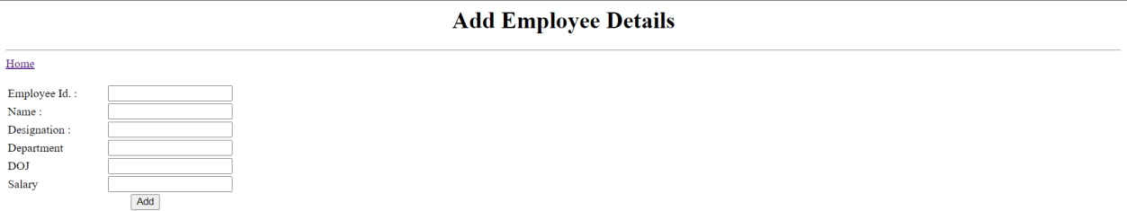

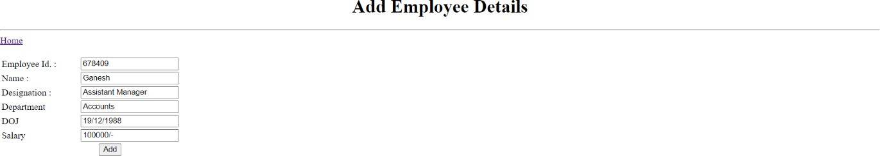

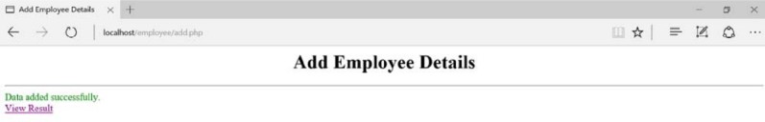

**Result:**

Hence,PHP program for Employee Details, which includes EmpID, Name, Designation, Salary, DOJ, etc., to connect with the database and execute queries to retrieve and update data is exceuted successfully.

EXPT NO: BOOTSTRAP – WEB PAGE DATE:

# Aim:

Program to develop an attractive web pages using Bootstrap.

# Procedure:

1. File Setup:
   * Create `index.html`, `styles.css`, and `scripts.js` files.
   * Ensure they are in the same directory for easy access.
2. Bootstrap Integration:
   * Link Bootstrap CSS in the HTML file using the CDN (Content Delivery Network)

<link href="https://stackpath.bootstrapcdn.com/bootstrap/4.5.2/css/bootstrap.min.cssr el="stylesheet">

1. HTML Structure:
   * Set up the basic structure of `index.html`.
   * Organize sections such as "About Me," "Portfolio," and "Contact."
2. Content Integration:
   * Add relevant content to each section.
   * Include text, images, and links to showcase your work and skills.
3. Customization and Styling:
   * Customize the appearance using custom CSS in `styles.css`.
   * Adjust Bootstrap classes and add additional styles as needed for a personalized look.

# PROGRAM:

<!DOCTYPE html>

<html lang="en">

<head>

<title>My Portfolio</title>

<!-- Bootstrap CSS -->

<link href="https://stackpath.bootstrapcdn.com/bootstrap/4.5.2/css/bootstrap.min.css" rel="stylesheet">

<!-- Font Awesome -->

<link href="https://cdnjs.cloudflare.com/ajax/libs/font- awesome/5.15.3/css/all.min.css" rel="stylesheet">

<!-- Custom CSS -->

<link href="styles.css" rel="stylesheet">

</head>

<body>

<!-- Navigation -->

<nav class="navbar navbar-expand-lg navbar-dark bg-dark">

<div class="container">

<a class="navbar-brand" href="#">My Portfolio</a>

<button class="navbar-toggler" type="button" data-toggle="collapse" data-target="#navbarNav" aria-controls="navbarNav" aria-expanded="false" aria-label="Toggle navigation">

<span class="navbar-toggler-icon"></span>

</button>

<div class="collapse navbar-collapse" id="navbarNav">

<ul class="navbar-nav ml-auto">

<li class="nav-item">

<a class="nav-link" href="#about">About</a>

</li>

<li class="nav-item">

<a class="nav-link" href="#portfolio">Portfolio</a>

</li>

<li class="nav-item">

<a class="nav-link" href="#contact">Contact</a>

</li>

</ul>

</div>

</div>

</nav>

<!-- About Section -->

<section id="about" class="py-5">

<div class="container">

<div class="row">

<div class="col-lg-6">

<h2>About Me</h2>

<p>Growing up, I played a lot of video games and always wondered how these video games are made. Eventually, I got to learn a lot of cool stuff about game development. The fact that I could make games made me feel excited. To be honest, when I was a kid, all I wanted to do was fix a bug in a particular game that was annoying me and spoiling the whole experience. That was when I found my passion. From that day onward, I've been learning, exploring, and, more importantly, debugging how to make games.

</p>

</div>

<div class="col-lg-6">

<img src="image.jpeg" alt="Profile Picture" class="img-fluid rounded-circle" width="250px">

</div>

</div>

</div>

</section>

<!-- Portfolio Section -->

<section id="portfolio" class="bg-light py-5">

<div class="container">

<h2 class="text-center mb-5">Portfolio</h2>

<div class="row">

<div class="col-md-4">

<div class="card">

<img src="image1.jpg" alt="Project 1" class="card-img-top">

<div class="card-body">

<h5 class="card-title">E-commerce Website</h5>

<p class="card-text">Developed a fully functional e- commerce website using HTML, CSS, and JavaScript, integrated with payment gateway and user authentication.</p>

<a href="#" class="btn btn-primary">View Project</a>

</div>

</div>

</div>

<div class="col-md-4">

<div class="card">

<img src="image2.webp" alt="Project 2" class="card-img-top">

<div class="card-body">

<h5 class="card-title">Portfolio Website</h5>

<p class="card-text">Designed and built a responsive portfolio website to showcase personal projects, skills, and experiences using Bootstrap and custom CSS.</p>

<a href="#" class="btn btn-primary">View Project</a>

</div>

</div>

</div>

</div>

</div>

</section>

<!-- Contact Section -->

<section id="contact" class="py-5">

<div class="container">

<h2 class="text-center mb-5">Contact Me</h2>

<div class="row">

<div class="col-md-6">

<form>

<div class="form-group">

<label for="name">Name</label>

<input type="text" class="form-control" id="name">

</div>

<div class="form-group">

<label for="email">Email address</label>

<input type="email" class="form-control" id="email">

</div>

<div class="form-group">

<label for="message">Message</label>

<textarea class="form-control" id="message" rows="3"></textarea>

</div>

<button type="submit" class="btn btn- primary">Submit</button>

</form>

</div>

<div class="col-md-6">

<div class="card bg-primary text-white">

<div class="card-body">

<h5 class="card-title">Get In Touch</h5>

<p class="card-text">Feel free to contact me if you have any questions or inquiries!</p>

</div>

</div>

</div>

</div>

</div>

</section>

<!-- Bootstrap JS and dependencies -->

<script src="https://code.jquery.com/jquery-3.5.1.slim.min.js"></script>

<script src=["http](https://cdn.jsdelivr.net/npm/%40popperjs/core%402.5.4/dist/umd/popper.min.js)s[://cdn.jsdelivr.net/npm/@popperjs/core@2.5.4/dist/umd/popper.min.js](https://cdn.jsdelivr.net/npm/%40popperjs/core%402.5.4/dist/umd/popper.min.js) "></script>

<script src="https://stackpath.bootstrapcdn.com/bootstrap/4.5.2/js/bootstrap.min.js"></s cript>

</body>

</html>

# OUTPUT:

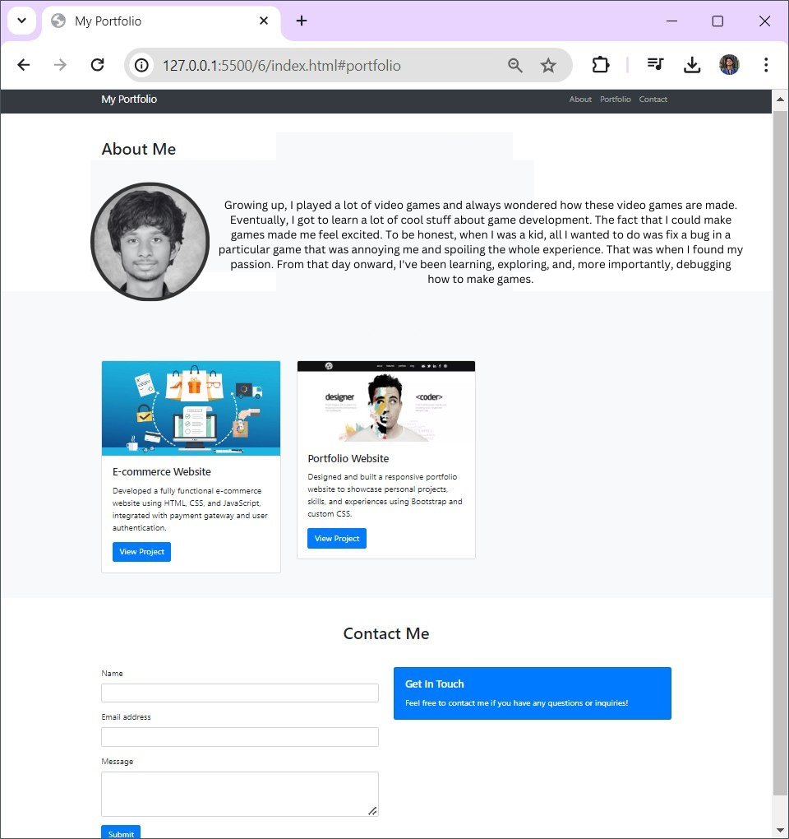

**RESULT:**

Hence developed an attractive web pages using Bootstrap.

EXPT NO: DESIGN A WEB PAGE WITH - NAVIGATION MENU DATE:

# AIM:

Program to design a web page with navigation menus using Angular JS.

# PROCEDURE:

1. Using Angular's directives to set and read the active variable.
2. When it changes, it causes the HTML that uses it to be updated automatically.
3. In Angular's terminology, this variable is called a model. It is available to all directives in the current scope, and can be accessed in your controllers (more on that in the nextexample).
4. JavaScript templates are with the {{var}} syntax, the framework sees such a string, it replaces it with the contents of the variable.
5. This operation is repeated every time var is changed.

# PROGRAM:

**Index.html:**

<!DOCTYPE html>

<html>

<head>

<link rel="stylesheet" href="style.css">

<script src="https://code.angularjs.org/1.2.13/angular.js"></script>

<script src="//cdnjs.cloudflare.com/ajax/libs/angular-material-icons/0.7.1/ angular-material-icons.min.js"></script>

<script src="app.js"></script>

</head>

<body>

<!-- Adding the ng-app declaration to initialize AngularJS -->

<div id="main" ng-app="navApp">

<nav class="{{active}}" ng-click="$event.preventDefault()">

<h2>Shopping Site</h2>

<a href="#" class="home" ng-click="active='home'">

<ng-md-icon icon="home" style="fill:white"></ng-md-icon>

</a>

<a href="#" class="electronics" ng-click="active='electronics'"> Electronics</a>

<a href="#" class="appliances" ng-click="active='appliances'"> Appliances</a>

<a href="#" class="clothing" ng-click="active='clothing'"> Clothing</a>

</nav>

<p ng-hide="active">Please click a menu item</p>

<p ng-show="active">You chose <b>{{active}}</b></p>

</div>

</body>

</html>

**STYLES.CSS:**

*{

margin:0; padding:0;

}

body{

font:15px/1.3 'Open Sans', sans-serif; color: #5e5b64;

text-align:center;

}

a, a:visited { outline:none;

color:#389dc1;

}

a:hover{

text-decoration:none;

}

a img{

display:inline-block;

}

section, footer, header, aside, nav{ display: block;}

nav{

display:inline-block; margin:60px auto 45px; background-color:#5597b4; box-shadow:0 1px 1px #ccc; border-radius:2px;

}

nav h2{

color:#fff !important;

}

nav a{

display:inline-block; padding: 18px 30px; color:#fff !important; font-weight:bold; font-size:16px;

text-decoration:none !important; line-height:1;

text-transform: uppercase; background-color:transparent;

-webkit-transition:background-color 0.25s;

-moz-transition:background-color 0.25s; transition:background-color 0.25s;

}

nav a:first-child{

border-radius:2px 0 0 2px;

}

nav a:last-child{

border-radius:0 2px 2px 0;

}

nav.home .home, nav.electronics .electronics, nav.appliances .appliances, nav.clothing .clothing{

color:yellow !important;

}

p{

font-size:22px;

font-weight:bold; color:#7d9098;

}

**OUTPUT:**

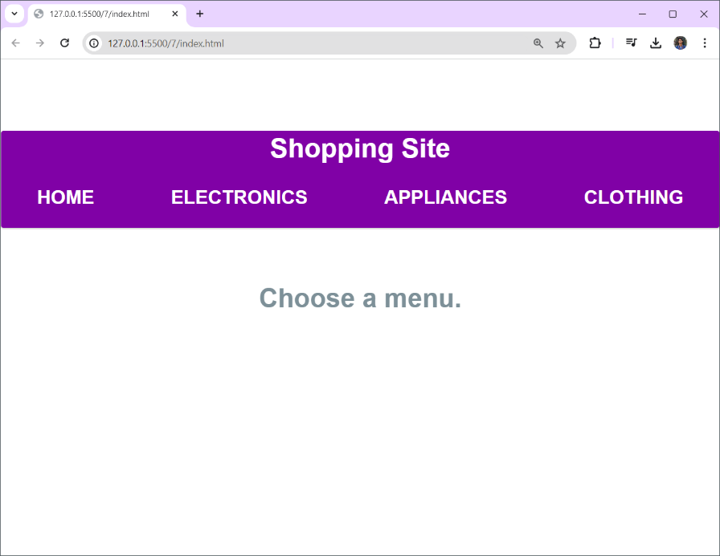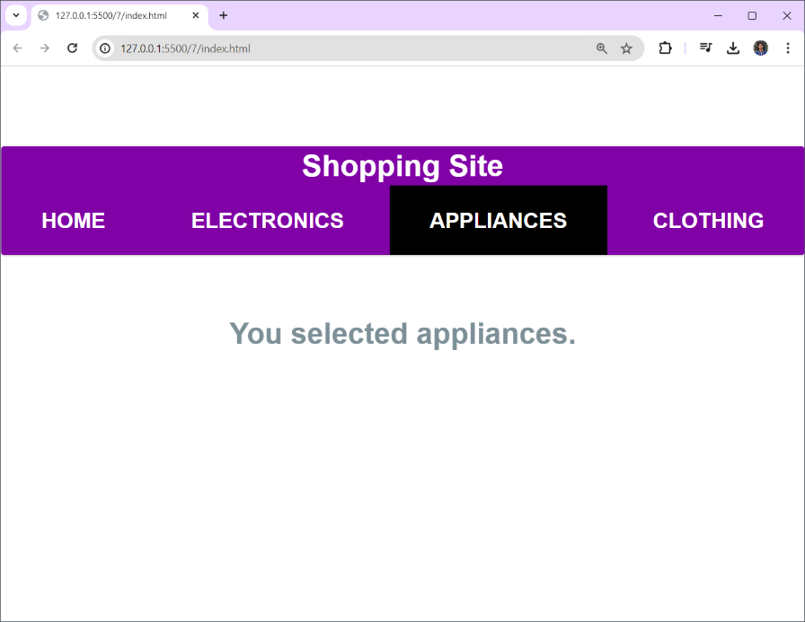

**RESULT:**

Hence designed a web page with navigation menus using Angular JS.

DESIGN A WEB PAGE WITH – INLINE EDITOR

# AIM:

Program to design a web page with inline editor using Angular JS.

# PROCEDURE:

1. Clicking a paragraph will show a tooltip with a text field.
2. Use a controller that will initialize the models and declare two methods for toggling the visibility of the tooltip.
3. Controllers are regular JavaScript functions which are executed automatically by Angular,and which are associated with your page using the ng-controller directive.
4. When the controller function is executed, it gets the special $scope object as a parameter.
5. Adding properties or functions to it makes them available to the view.
6. Using the ng-model binding on the text field tells Angular to update that variable when thevalue of the field changes (this in turn re-renders the paragraph with the value).

# PROGRAM:

<!DOCTYPE html>

<html lang="en" ng-app="inlineEditorApp">

<head>

<title>Bootstrap & AngularJS Inline Editor</title>

<link rel="stylesheet" href="https://stackpath.bootstrapcdn.com/bootstrap/4.5.2/css/bootstrap.min.css"

>

<link rel="stylesheet" href="https://cdnjs.cloudflare.com/ajax/libs/font- awesome/5.15.3/css/all.min.css">

<style>

.center { display: flex;

justify-content: center; align-items: center; height: 100vh;

}

.title-container { display: flex;

align-items: center;

}

.title {

margin: 0;

font-size: 24px; font-weight: bold;

}

.edit-btn {

margin-left: 10px;

}

</style>

</head>

<body>

<div ng-controller="InlineEditorController as ctrl" class="container center">

<div class="title-container">

<h1 class="title" ng-hide="ctrl.editingTitle">{{ ctrl.title }}</h1>

<div ng-show="ctrl.editingTitle" class="input-group">

<input type="text" class="form-control" ng-model="ctrl.title" id="title" aria-label="Title" aria-describedby="basic-addon2">

<div class="input-group-append">

<button class="btn btn-outline-secondary" type="button" ng- click="ctrl.saveField('title')"><i class="fas fa-check"></i></button>

</div>

</div>

</div>

<button class="btn btn-outline-secondary edit-btn mt-3" type="button" ng- click="ctrl.editField('title')">

<i class="fas fa-pencil-alt"></i> Edit Title

</button>

</div>

<script src="https://ajax.googleapis.com/ajax/libs/angularjs/1.8.2/angular.min.js"></scri pt>

<script src="https://code.jquery.com/jquery-3.5.1.slim.min.js"></script>

<script src="https://cdnjs.cloudflare.com/ajax/libs/font- awesome/5.15.3/js/all.min.js"></script>

<script> angular.module('inlineEditorApp', [])

.controller('InlineEditorController', function() { var ctrl = this;

ctrl.title = "Click to edit me"; ctrl.editingTitle = false; ctrl.editField = function(field) {

ctrl.editingTitle = true; setTimeout(function() {

document.getElementById(field).focus();

});

};

ctrl.saveField = function(field) {

ctrl.editingTitle = false;

};

});

</script>

</body>

</html>

# OUTPUT:

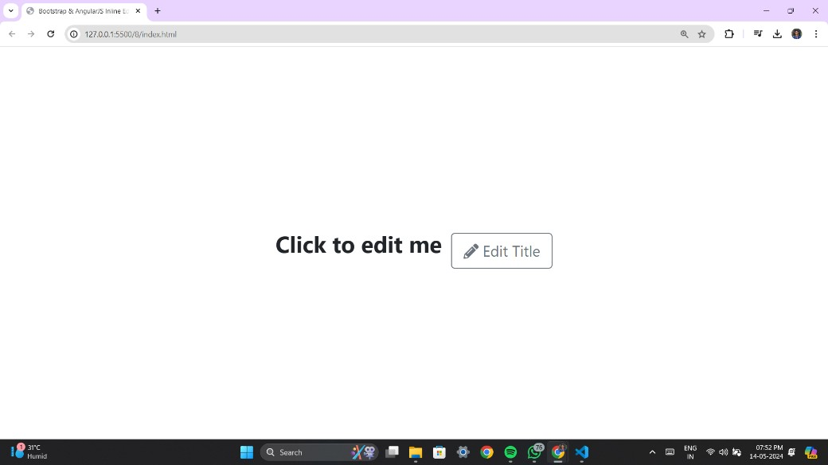

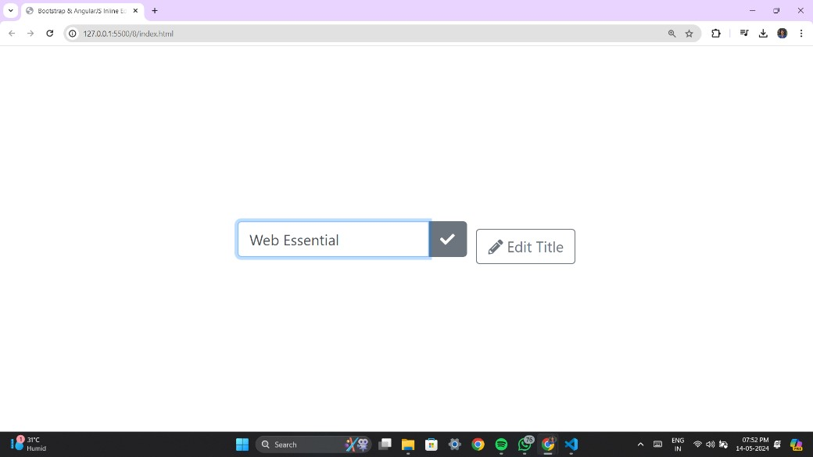

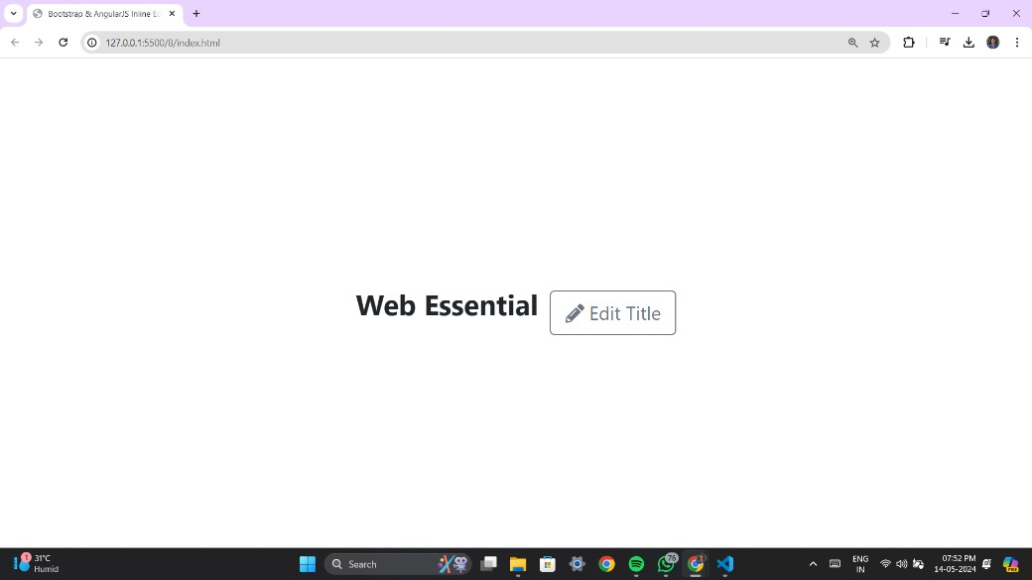

**RESULT:**

Hence designed a web page with inline editor using Angular JS.

DESIGN A WEB PAGE WITH – ORDER FORM

# AIM:

Program to design a web page with order form using Angular JS.

# PROCEDURE:

1. Code an order form with a total price updated in real time, using another one of Angular's useful features - filters.
2. Filters let modify models and can be chained together using the pipe character.
3. Use the currency filter, to turn a number into a properly formatted price, complete with a dollar sign and cents. You can easily make your own filters.
4. The ng-repeat binding (docs) is another useful feature of the framework. It lets loop through an array of items and generate markup for them. It is intelligently updated when an item is changed or deleted.

# PROGRAM:

<!DOCTYPE html>

<html lang="en" ng-app="orderFormApp">

<head>

<meta charset="UTF-8">

<title>Order Form</title>

<link rel="stylesheet" href="https://stackpath.bootstrapcdn.com/bootstrap/4.5.2/css/bootstrap.min.css"

>

<style>

body, html { height: 100%;

}

.container {

display: flex;

justify-content: center; align-items: center; height: 100%;

}

order-form {

max-width: 400px; width: 100%;

}

form-group {

margin-bottom: 20px;

}

form-label {

font-weight: bold;

}

</style>

</head>

<body>

<div ng-controller="OrderFormController as formCtrl" class="container">

<form class="order-form">

<div class="form-group">

<label for="products" class="form-label">Products:</label>

<select multiple class="form-control" id="products" ng- model="formCtrl.selectedProducts" ng-options="product as product.name for product in formCtrl.products">

</select>

</div>

<div class="form-group">

<label for="quantity" class="form-label">Quantity:</label>

<input type="number" class="form-control" id="quantity" ng- model="formCtrl.quantity">

</div>

<button type="button" class="btn btn-primary" ng- click="formCtrl.addToCart()">Add to Cart</button>

<div class="form-group mt-3">

<label class="form-label">Cart:</label>

<ul class="list-group">

<li class="list-group-item" ng-repeat="item in formCtrl.cart">{{ item.product.name }} - Quantity: {{ item.quantity }} - Total: ${{ item.total

}}</li>

</ul>

<p class="mt-3">Grand Total: ${{ formCtrl.grandTotal }}</p>

</div>

</form>

</div>

<script src="https://ajax.googleapis.com/ajax/libs/angularjs/1.8.2/angular.min.js"></scri pt>

<script> angular.module('orderFormApp', [])

.controller('OrderFormController', function() { var formCtrl = this;

formCtrl.products = [

{ name: 'Web Essentials', cost: 100 },

{ name: 'Web Hosting', cost: 50 },

{ name: 'Domain Registration', cost: 20 }

];

formCtrl.selectedProducts = []; formCtrl.quantity = ""; formCtrl.cart = []; formCtrl.grandTotal = 0;

// Function to add item to cart formCtrl.addToCart = function() {

if (formCtrl.selectedProducts.length && formCtrl.quantity) { angular.forEach(formCtrl.selectedProducts, function(product) { var total = product.cost * formCtrl.quantity;

formCtrl.cart.push({ product: product, quantity: formCtrl.quantity, total: total });

formCtrl.grandTotal += total;

});

// Clear input fields after adding to cart formCtrl.selectedProducts = []; formCtrl.quantity = "";

} else {

console.log("Please select product(s) and enter a quantity.");

}

};

});

</script>

</body>

</html>

# OUTPUT:

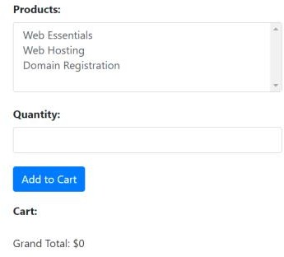

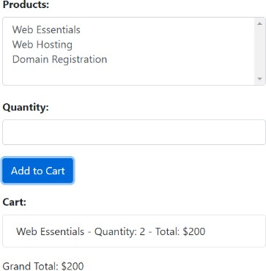

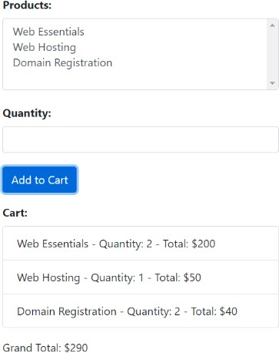

**RESULT:**

Hence designed a web page with order form using Angular JS.

DESIGN A WEB PAGE WITH – INSTANT SEARCH

# AIM:

Program to design a web page with instant search using Angular JS.

# PROCEDURE:

1. To filter a list of items by typing into a text field.
2. First have to turn the application into a module.
3. Modules are a way of organizing JavaScript applications into self-contained componentsthat can be combined in new and interesting ways.
4. Angular relies on this technique for code isolation and requires that your applicationfollows it before you can create a filter.
5. There are only two things that you need to do to turn your app into a module:
   1. Use the angular.module("name",[]) function call in your JS. This will instantiate and return a new module;
   2. Pass the name of the module as the value of the ng-app directive.
6. Creating a filter then is as simple as calling the filter() method on the module object returned by angular.module("name", []).

# PROGRAM:

<!DOCTYPE html>

<html lang="en" ng-app="instantSearchApp">

<head>

<meta charset="UTF-8">

<title>Instant Search - Engineering Departments</title>

<link rel="stylesheet" href="https://stackpath.bootstrapcdn.com/bootstrap/4.5.2/css/bootstrap.min.css"

>

</head>

<body>

<div ng-controller="SearchController as searchCtrl" class="container mt-5">

<h1>Instant Search - Engineering Departments</h1>

<input type="text" class="form-control mt-3" placeholder="Search..." ngmodel="searchCtrl.query">

<ul class="list-group mt-3">

<li class="list-group-item" ng-repeat="department in searchCtrl.departments

| filter:searchCtrl.query">{{ department }}</li> </ul>

</div>

<script src="https://ajax.googleapis.com/ajax/libs/angularjs/1.8.2/angular.min.js"></scri pt>

<script> angular.module('instantSearchApp', [])

.controller('SearchController', function() { var searchCtrl = this; searchCtrl.departments = [

'Computer Science and Engineering', 'Computer Science and Design', 'Electrical and Electronics Engineering', 'Mechanical Engineering',

'Civil Engineering',

'Electronics and Communication Engineering', 'Chemical Engineering',

'Biomedical Engineering', 'Aerospace Engineering', 'Environmental Engineering', 'Materials Science and Engineering'

];});

</script>

</body>

</html>

# OUTPUT:

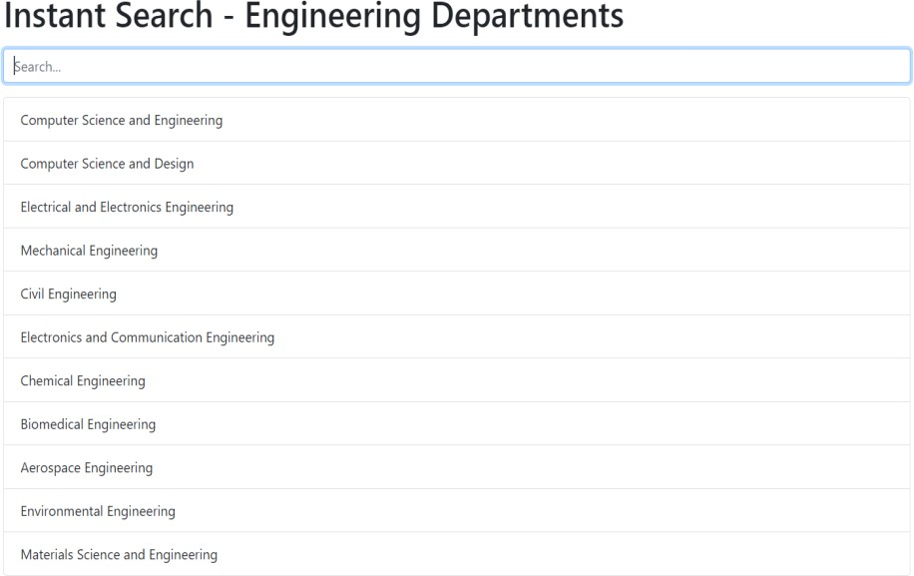

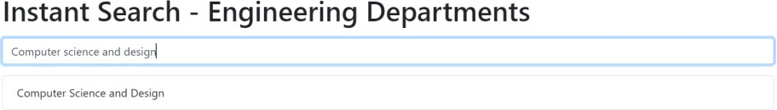

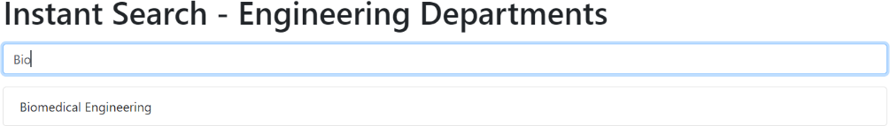

**RESULT:**

Hence designed a web page with instant search using Angular JS.

DESIGN A WEB PAGE WITH – SWITCHABLE GRID

# Aim:

Program to design a web page with Switchable grid using Angular JS.

# Procedure:

1. Create the HTML structure for the switchable grid interface. Include buttons for switching between grid and list views and define containers for displaying the grid and list.
2. Set up an AngularJS module and controller to manage the functionality of the switchable grid. Inject the AngularJS library into the HTML file.
3. Initialize data and view: Define a sample list of items and initialize the default view to be displayed (in this case, the grid view).
4. Create a function in the AngularJS controller to switch between grid and list views. This function will change the value of a variable representing the current view.
5. Use AngularJS directives such as ng-show and ng-repeat to bind the data to the grid and list views. Show or hide each view based on the current view variable, and iterate over the list of items to display them in the respective views.

# PROGRAM:

<!DOCTYPE html>

<html lang="en" ng-app="switchableViewApp">

<head>

<meta charset="UTF-8">

<title>Switchable Grid</title>

<link rel="stylesheet"

href="https://stackpath.bootstrapcdn.com/bootstrap/4.5.2/css/bootstrap.min.css"

>

<style>

.container {

max-width: 600px;

}

h1 {

margin-bottom: 30px;

}

.btn-group {

margin-bottom: 20px;

}

.view-button { margin-right: 10px;

}

.card {

height: 100%;

}

.list-group-item { cursor: pointer;

}

</style>

</head>

<body>

<div ng-controller="SwitchableGridController as gridCtrl" class="container mt- 5">

<h1>Switchable Grid</h1>

<div class="btn-group">

<button class="btn btn-primary view-button" ng- click="gridCtrl.switchView('grid')">Grid View</button>

<button class="btn btn-primary view-button" ng- click="gridCtrl.switchView('list')">List View</button>

</div>

<div ng-show="gridCtrl.currentView === 'grid'" class="row">

<div class="col-md-4 mb-3" ng-repeat="item in gridCtrl.items">

<div class="card">

<div class="card-body">

{{ item }}

</div>

</div>

</div>

</div>

<div ng-show="gridCtrl.currentView === 'list'">

<ul class="list-group">

<li class="list-group-item" ng-repeat="item in gridCtrl.items">{{ item

}}</li>

</ul>

</div>

</div>

<script src="https://ajax.googleapis.com/ajax/libs/angularjs/1.8.2/angular.min.js"></scri pt>

<script> angular.module('switchableViewApp', [])

.controller('SwitchableGridController', function() { var gridCtrl = this;

gridCtrl.items = [

'Item 1', 'Item 2', 'Item 3', 'Item 4', 'Item 5'

];

gridCtrl.currentView = 'grid'; gridCtrl.switchView = function(view) { gridCtrl.currentView = view;

};

});

</script>

</body>

</html>

# OUTPUT:

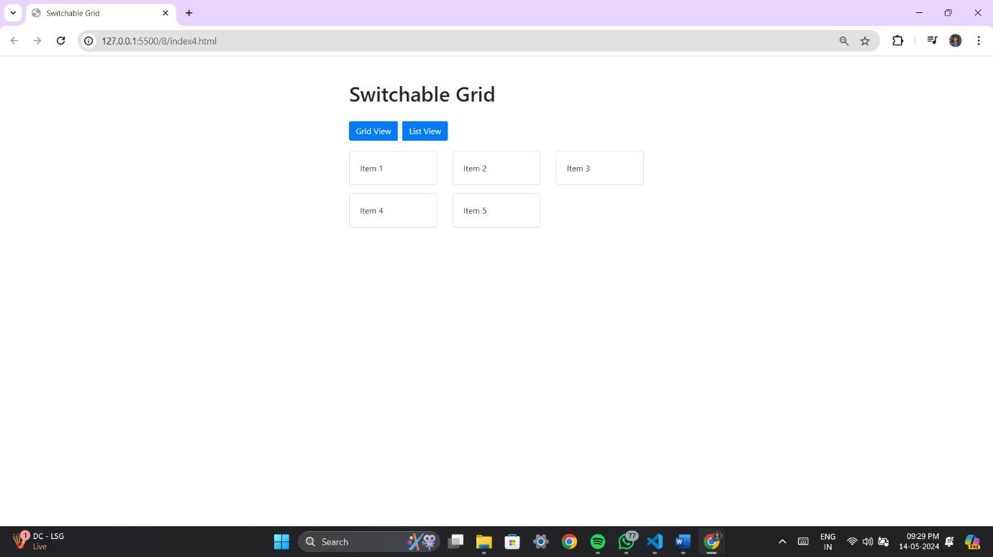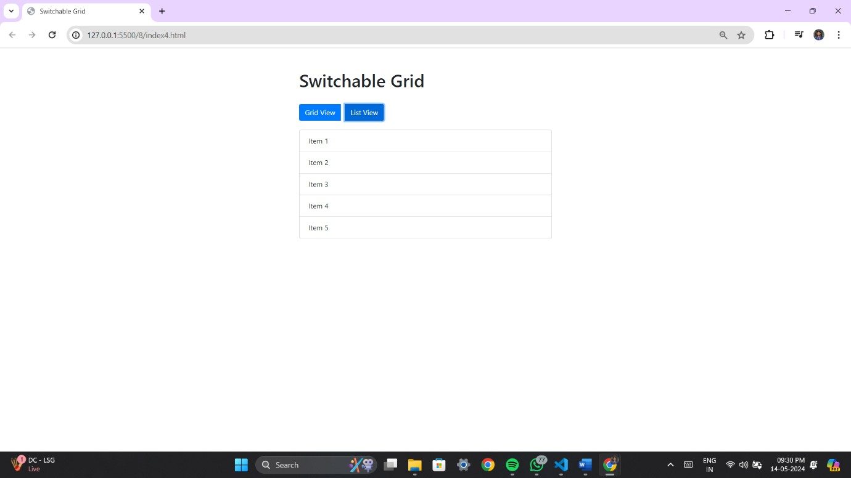

**RESULT:**

Hence designed a web page with Switchable grid using Angular JS.

EXPT NO: SINGLE PAGE APPLICATION DATE:

# AIM:

Program to develop an single page application using angular js.

# PROCEDURE:

1. Make a single page application and don’t want any page refreshes, use Angular’s routing capabilities.
2. Include angular-route script after the main angular script. 8. Specify that the module depends on ngRoute module to be able to use it.
3. The next thing is to distinguish common HTML for every page. This HTML will be layout of the website.
4. Then specify the place where HTML of each page will be placed in our layout. There is a ng-view directive for that.
5. ng-view is an Angular directive that will include the template of the current route (for example, /blog or /about) in the main layout file.
6. Configure the routes. Use $routeProvider service from the ngRoute module.
7. For each route, specify templateUrl and controller.
8. If user will try to go to the route that does not exist, handle this by using otherwise function. In our case, we will redirect user to the “/” route:
9. Build controllers for every route (already specified their names in routeProvider).

# PROGRAM:

<!DOCTYPE html>

<html ng-app="myApp">

<head>

<meta charset="UTF-8">

<title>Single Page Application</title>

<link rel="stylesheet" href="https://stackpath.bootstrapcdn.com/bootstrap/4.5.2/css/bootstrap.min.css"

>

<style>

body {

font-family: Arial, sans-serif; margin: 0;

padding: 0;

background-color: #f4f4f4;

}

#navbar {

background-color: #333; overflow: hidden; display: flex;

justify-content: center; align-items: center; width: 100%; position: fixed;

top: 0;

}

#navbar a { display: block; color: white;

text-align: center; padding: 14px 16px; text-decoration: none;

}

#navbar a:hover { background-color: #555;

}

#navbar a.active {

background-color: #4CAF50;

}

.content { padding: 20px;

text-align: center;

margin-top: 60px; /* Adjusted margin to make space for navbar */

}

h1 {

margin-top: 0;

}

img {

max-width: 100%; height: auto; border-radius: 5px;

margin-bottom: 20px;

}

</style>

<script src="https://cdnjs.cloudflare.com/ajax/libs/angular.js/1.4.7/angular.min.js"></sc ript>

<script src="https://cdnjs.cloudflare.com/ajax/libs/angular.js/1.4.7/angular- route.min.js"></script>

</head>

<body>

<div id="navbar">

<a href="#/" class="active">Home</a>

<a href="#/courses">Courses</a>

<a href="#/contactus">Contact Us</a>

</div>

<div ng-view class="content"></div>

<script type="text/ng-template" id="pages/home.html">

<div class="container">

<h1>Home</h1>

<img src="image.jpeg" alt="Default Image">

<h3>{{ message }}</h3>

</div>

</script>

<script type="text/ng-template" id="pages/courses.html">

<div class="container">

<h1>Courses</h1>

<h3>{{ message }}</h3>

<ul class="list-group">

<li class="list-group-item" ng-repeat="course in courses">{{ course

}}</li>

</ul>

</div>

</script>

<script type="text/ng-template" id="pages/contactus.html">

<div class="container">

<h1>Contact Us</h1>

<h3>{{ message }}</h3>

<p>Rajalakshmi Nagar, Thandalam, Chennai - 602 105</p>

</div>

</script>

<script>

var app = angular.module('myApp', ['ngRoute']); app.config(function($routeProvider) {

$routeProvider

.when('/', {

templateUrl: 'pages/home.html', controller: 'HomeController'

})

.when('/courses', {

templateUrl: 'pages/courses.html', controller: 'CoursesController'

})

.when('/contactus', {

templateUrl: 'pages/contactus.html', controller: 'ContactUsController'

});

})

.otherwise({ redirectTo: '/'

});

app.controller('HomeController', function($scope) {

$scope.message = 'Welcome to REC';

});

app.controller('CoursesController', function($scope) {

$scope.message = 'Courses Offered';

$scope.courses = [

'AERO', 'AUTO', 'BIOMED', 'BIOTECH', 'CHEMICAL',

'CIVIL', 'CSE', 'CSD', 'CSBS', 'ECE', 'EEE', 'FT', 'IT', 'MCT', 'MECH'

];

});

app.controller('ContactUsController', function($scope) {

$scope.message = 'Contact Us';

});

</script>

</body>

</html>

# OUTPUT:



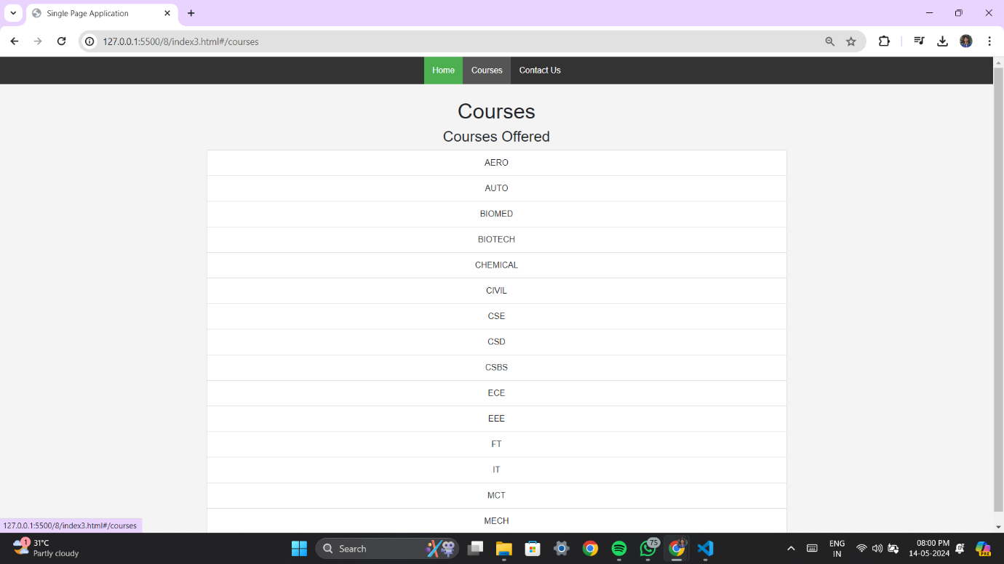

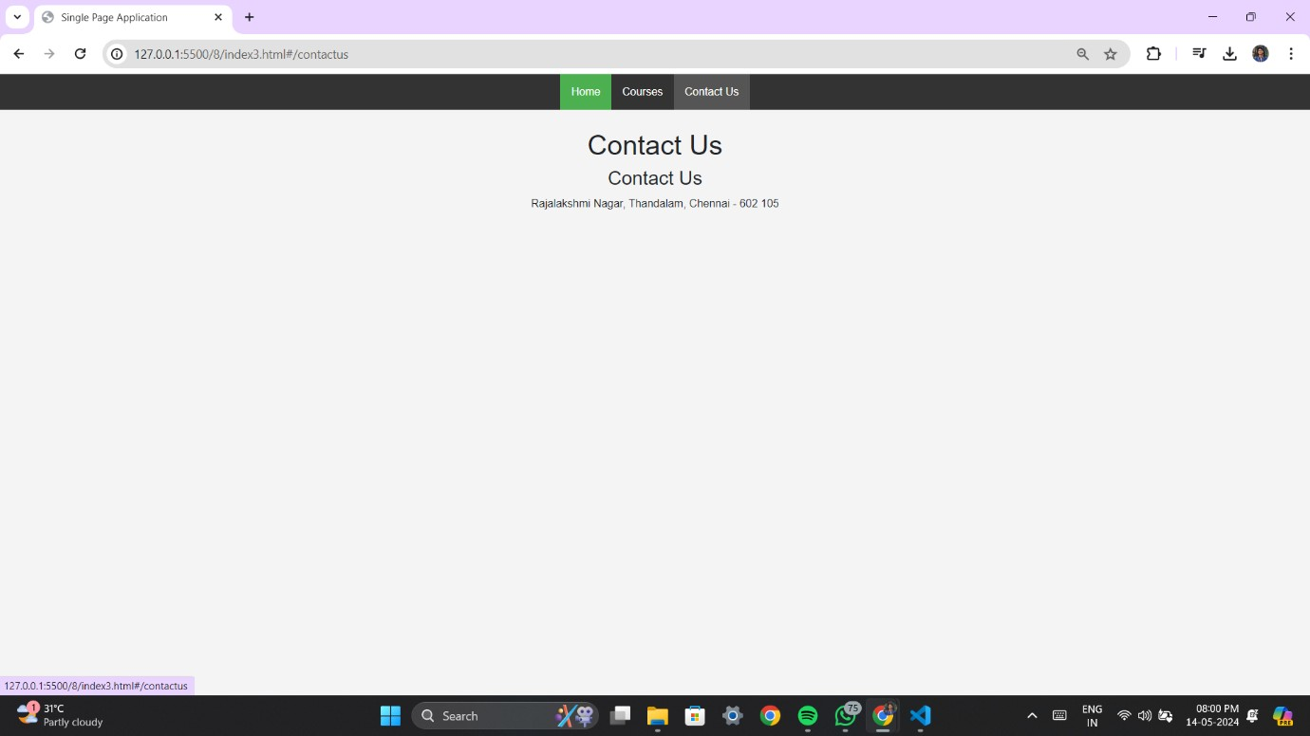

**RESULT:**

Hence developed a single page application using Angular JS.